SPARKOLE 12V Battery Pack Rechargeable 5200mAh Lithium Ion Battery

for LED Strip/CCTV Camera/Electronic Organ/Optical Network Unit/Router,Portable 12 Volt Battery DC5521 Interface (Blue)

|  |  |
| --- | --- |
| Number of Batteries | 1 Lithium Ion batteries required. |
| Brand | SPARKOLE |
| Battery Cell Composition | Lithium Ion |
| Recommended Uses For Product | Router, Camera |
| Unit Count | 1 Count |

# About this item

* 【5200mAh Large Capacity】 It is made of high-quality lithium-ion battery. The large capacity of 5200mAh can provide longer running time, which can be used for 1.5-2 hours each time. Small and convenient, easy to carry, almost can be used as the strongest auxiliary outdoor.
* 【Strong Compatibility】Small size, compatible with most 12V devices. Compatible with LED Strip, CCTV Camera, electronic organ, Optical Network Unit, router, small Bluetooth Amp, Car DVR, speaker, Walkie-Talkies, Portable DVDs, Digital Cameras, binoculars, etc.
* 【Smart Chip】5200mAh rechargeable lithium battery, built-in upgraded smart chip, provide over-charge protection, over-discharge protection, over-voltage protection, over-current protection, over-heating protection, short circuit protection for the battery to protect you The equipment is not damaged.
* 【High Quality PVC Material】 DC5521 1 Female and 1 Male Cable, the flame retardant safety factor of selected PVC materials is upgraded. Anti-aging, anti-corrosion, anti-cracking, wear-resistant and pressure-resistant. Suitable for 12.6V/1A DC/AC Charger (Note: Charger Not Included)
* 【Customer Support】Sparkole provides a 35-day refund and 1-year warranty and 24-hour customer support. If you encounter any problems, please feel free to contact us.

## Product Description

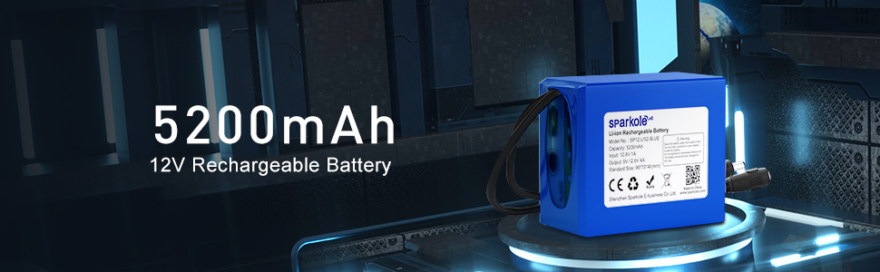

# 5200mAh 12V Rechargeable Lithium-ion Battery

General Parameter:

Rated Capacity: 5200 mAh Charging Voltage: 12.6V

Internal Impedance: ≤180mΩ

Standard Charging Time: 6 hours Fast Charging Time: 3 hours

Maximum Continuous Charge Current: 3A

Operation Temperature Range: Charge:0~45°C Discharge：-20~60°C

Battery Dimensions: length: 3.14in Width: 2.7in Thickness: 1.5in

Battery Pack Weight: 338g/0.74lb

Charge and Discharge line length: 210mm

Input DC2.1 Female Max: 12.6V 6A Output DC2.1 Male Max: 12V 6A

|  |  |  |
| --- | --- | --- |
|  |  |  |
| 12v Battery Pack Built-in Upgrade Smart Chip Provide overcharge, overvoltage, overheating, and short circuit protection for your charging equipment.Charging is safe, smart and guaranteed. | DC5521 interface 1 Female and 1 Male Cable Input DC2.1 Female Max: 12.6V 6A  Output DC2.1 Male Max: 12V 6A  Connector: 5.5 x 2.1 mm  Suitable for 12.6V/1A DC/AC Charger  (Note: Charger Not Included) | High-quality PVC Material for Charging Port, Anti-aging and Anti-corrosion Sparkole 5.5*2.1 Male has close contact and good performance. The flame retardant safety factor of selected PVC materials is upgraded. Anti-aging, anti-corrosion, anti-cracking, wear-resistant and pressure-resistant, after 5000+ bending tests, the factory has undergone strict inspections, quality is guaranteed. |

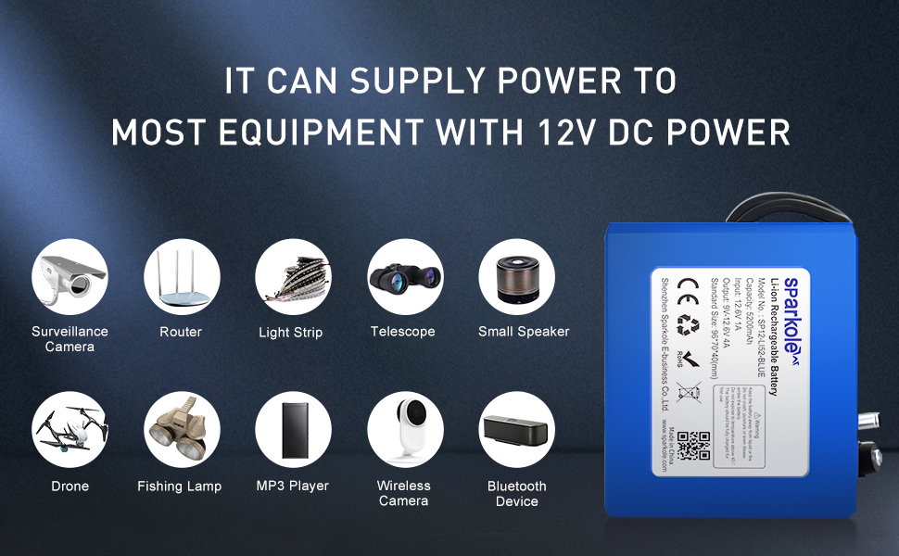

### Compatible with Most of 12V Devices

Lightweight and Easy to Carry, Only 0.74lb, Supports a Variety of 12v Devices, Just Like:

* Surveillance Cameras
* Router
* Light Strip
* Telescope
* Small Speakers
* Fishing Lamp
* MP3 Player
* Wireless Camera
* Bluetooth Device
* Small Bluetooth Amp
* LED Desk Lamp
* Metal Detector

Please Note:

1) Charge shall be done by voltage less than that specified in the Product Specification (12 .6V/battery );

2) The battery shall be charged within 0°C~45°C range in the Product Specification;

3) Prohibition of reverse charge: In case of the battery is connected improperly, the battery cannot be charged;

4) Never disassemble the cells: The disassembling may generate internal short circuit in the cell or other problems;

5) Prohibition of dumping of battery pack into fire;

6) Prohibition of battery immersion into liquid such as water;

7) Prohibition of use of damaged batteries.